**IBM ASSIGNMENT 2**

|  |  |
| --- | --- |
| Date | 19 September 2022 |
| Team ID | PNT2022TMID06453 |
| Name | VENKATESH BABU.N.S |
| Project Name | Project – Real-Time River Water Quality  Monitoring and Control System |

**1) Build a python code, Assume u get temperature and humidity values (generated with random function to a variable) and write a condition to continuously detect alarm in case of high temperature.**

**PROGRAM:**

import random

import time

while(1!=0):

temperature = random.random()

humidity = random.random()

print("Temperature: ","%.3f" % temperature)

print("Humidity: ","%.3f" % humidity)

time.sleep(2)

if (temperature > 0.5):

print("high temperature")

if ( humidity >0.5):

print("high humidity")

print(" ")

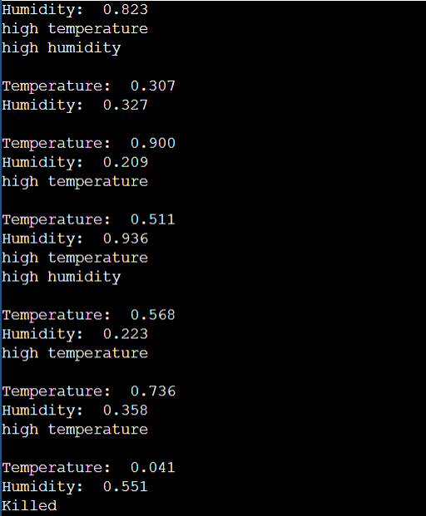**OUTPUT:**